# **VCADevice – Setting up special frame types for selection when confirming frame type after tracing.**

### **Process Description**

VCAdevice has a setting ‘Confirm Frame Type on Trace’ When a trace is received, the user sees the trace on screen and can specify the frame type just traced. This information is stored with the trace.

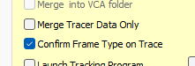

### By default this gives the user options to select Plastic, Metal, Rimless and Supra frame types.

### Sometimes further selection options are required for processing. This document describes how to define these and make them available for selection.

### **Step 1 – enable special Frame Type Option**

On the Configuration tab of VCAdevice there is the check box option Edging, MEI-

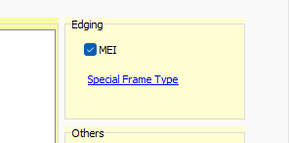

Tick this and the link label ‘Special Frame Type’ is shown. Now click this to see a further configuration screen : -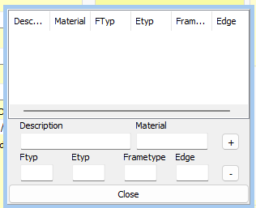

### **Step 2 – Adding Special Frame Types**

For example – adding a ‘Thick Supra’

Acceptable VCA-OMA standard values for **FTYP** are defined as below

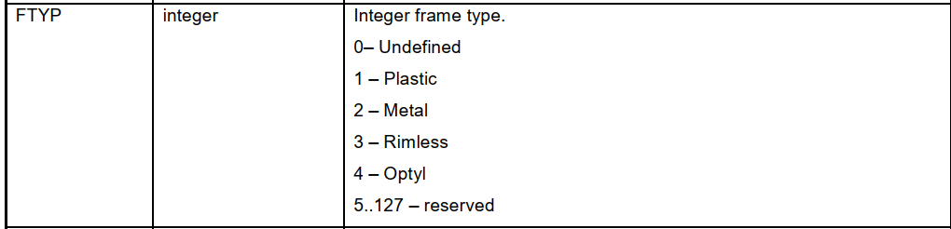

and for **ETYP t**he acceptable values are :

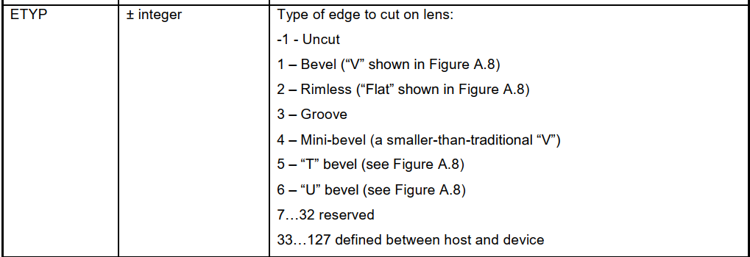

**Frametype values are :**

Plastic frame code = 0

Metal frame code = 1

Rimless frame code = 3

Supra frame code = 2

Thick Supra frame code = 4

Plastic Cold frame code = 5

Plastic Safety frame code = 6

Metal Safety frame code = 7

Thick Rimless frame code = 8

So you might set up your Thick Supra as :

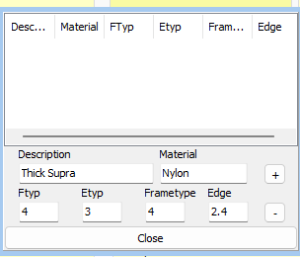

Where edge is the minimum required edge. Click + button to add the line and then OK.

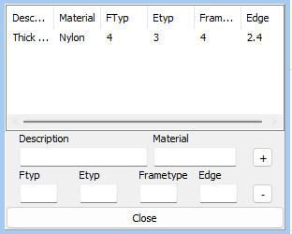

### **Completion – Restart VCAdevice and trace a frame to get new Specials option**

Now when you trace a frame and confirm the frame type, you get the extra option of ‘Specials’

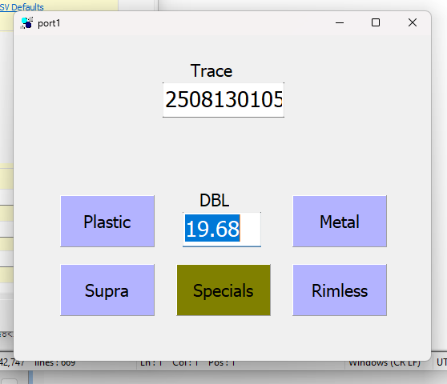

So when you click Special the list of specially defined glazing types is available to select from.

The trace is saved with the selected special glazing information.